Railroading Merit Badge

Requirement 2b Study Guide
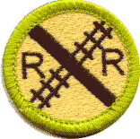
List and explain the various forms of Public/Mass Transit using rail as the fixed guide path.
The most common answer for this requirement is Commuter trains and Amtrak trains. They often come to mind because they use the same rails as freight services in the United States. But we have many other types of passenger transit which uses rail. The San Francisco Bay Area has many examples, but you can check all around North America, and many other countries for some of these other examples.

Light Rail (examples are San Jose's Valley Transit Authority, the Sacramento Regional Transit) - Light Rail trains usually use overhead electric power, electric motors under each coach, and using a rail gauge slightly different from standard trains. They normally operate away from regular train lines, and closer to metropolitan and urban population centers.  Photo of Sacramento RT Light Rail by Peter Ehrlich, 2007 | 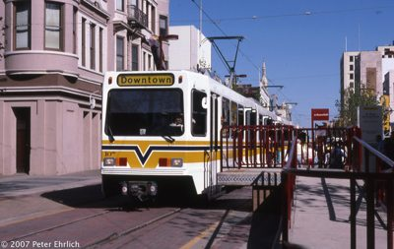

Third-Rail Trains (examples are San Francisco's Bay Area Rapid Transit, and the Washington, D.C. area Metro trains) - Each car has power pick-ups below the train body, from an Electric Third Rail, located near the two rails that serve as the fixed guide path.  (Montreal, Canada, and Paris, France have a thrid-rail underground system very similar to Bart, and Washington D.C.'s Metro, but they use rubber tires and concrete guideways instead of rails and rail wheels.) | 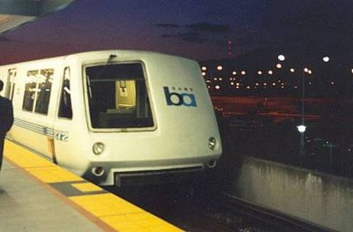

Subways (examples include San Franscisco MUNI, Massechusetts Bay Transit) - Subways are underground people-moving trains, and these days they are often electric motor systems, because it's difficult to clear the exhaust from petroleum-fueled motors from the subway tunnels. (Residue from petroleum exhaust also sticks to everything underground.) Underground operation helps these trains run reliably during bad weather conditions.  The Massachusets Bat Transit Authority Red Line (shown at right) is a third-rail powered system. | 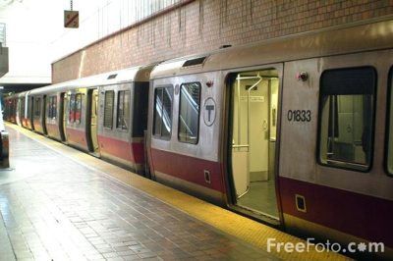

Street Cars, or Trolley Cars (examples are New Orleans Streetcars, Illinois Railway Museum trollys) - Many trolley cars used overhead electrical pickups, and rails as a fixed path.  Photo of IRM Car 321 by Frank Hicks, 2007  Many of the trolly lines in New Orleans were damaged by the floods, but they are being restored, becaue of the rich history they have in this famous city.  When cars and trolleys have to share the road in busy metropolitan areas, the fact that the rails can't swerve around stopped traffic often cause delays. In many areas, they have been replaced by Trolley Buses, which use the overhead wires and electric motors, but the buses ride on rubber tires, so the bus can move through traffic more easily. | 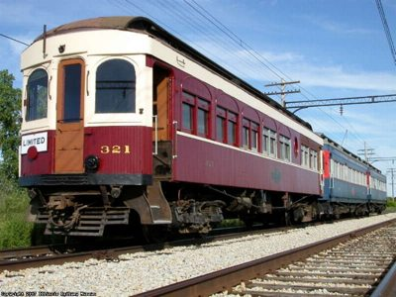

San Francisco Cable Cars - Unlike the electric or petroleum-based power used in the rest of the modes described on this page, the motive power for these cable cars is NOT part of the car!  How cable cars work: There are large motors, located in Power Houses, which move cables underground. The Gripman uses a device to grab the moving cable under the street to pull the car up and down the hills, and he uses brakes on the car to slow and stop the car.  Photo of cable car by Aude | 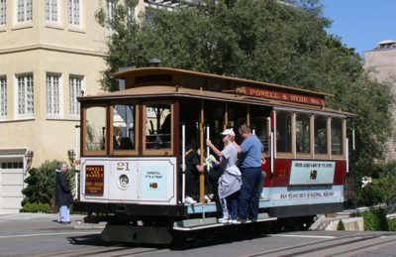

Monorail Systems (Schweberbahn, Wuppertal, Germany) - There are many monorails in service in amusement parks, but they often use rubber tires instead of rails. There is also a monorail operating in downtown Seattle, Washington, which also uses rubber tires under the cars.  There is a great Mass Transit monorail system called the Schwebebahn, in Wuppertal, Germany, which is suspended above the Wupper River, and they operate a variety of older and newer cars on the 8.3-mile line.  Photo of Schwebebahn trains by Daniel Kapanke | 