Railroading Merit Badge
Requirement 1c Study Guide
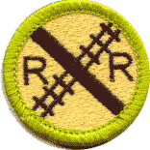
Using models or pictures, identify 10 types of railroad freight or passenger cars. Explain the purpose of each type of car.
There are a few basic types of freight cars, such as the Flatcar, the Hopper car the Boxcar, and the Tank car, but each type of car has a few special variations of that type of car. There are also some more recent specialty types of cars. And don't forget the Cabooses! This page will also show you how to spot different types of Passenger cars.
The pictures below are used here with permission of the photographers, to illustrate the various types of cars. If you click on most of the images, you'll get to see the full-size version. (Most of the 'big versions' will take you to the website with the original picture, and many of these off-site images are very large, and they may take a lot of time to load if you have a slow conection.)
If you are interested in seeing more pictures of different types of cars and locomotives in the paint jobs of various railroads, please check out these websites;
- David Graham's Railfan Archive
- http://railfan.ca/
- Chris vanderHeide's Canadian Freight Railcar Gallery
- http://freight.railfan.ca/
- Ryan Wilkerson's photos
- http://www.shastarails.com/
Please use the worksheet to make notes about the requirements that you are learning about to be signed off on the day of the Merit Badge Classes.

Flatcars
Flatcars were initially a simple platform, mounted on rail wheels, for moving freight. It was easy to load and unload, but it was also easy for freight to fall off during sudden stops and when taking curves at faster speeds. It was also easy for thieves to see (and steal) freight from the flatcars.  They remain a versatile freight platform today, and continue to be adapted for special uses. Imagine the weight of this large tractor.  Photo by Ryan Wilkerson. | 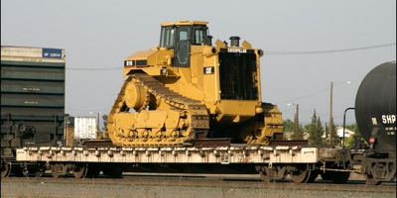

Trailer-on-Flatcar (TOFC) were flatcars designed to have a tractor trailer driven up a loading ramp onto the flatcar, and they had special supports for the front end of the trailer. These were sometimes referred to as "Piggyback Flatcars.  Some variations of TOFC used a crane to move the trailers between the ground and the flatcar. Both the crane-loaded, and the drive-on versions required special loading facilities.  Photo by David Graham. | 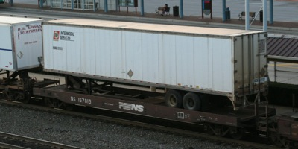
The Road-Railer is a hybrid system, where a road (truck) trailer was specially adapted to integrate with the railroad for transportation. The air brake system on road trailers is similar to the air brakes used on a railroad car. These trailers are built to be able to lift their road tires, allowing the trailer to latch onto special rail-wheel adapter trucks. One by one, the trailers are set onto their train wheels, and the air brakes are connected together, and then one (or more) locomotives canpull the string of trailers as a Unit Train.
Road-Railer Trains are "Bi-Modal", meaning that the trailers can be used in two modes of service (road and rail).  These tractor trailers have special features that make it quick and easy to connect them to special train wheelsets and raise their road wheels. At their rail destination, the road wheels are lowered, and another truck drives them to their final destination.  Notice in the picture that there is no 'train' under the trailer, which reduces the weight, and it also lowers the center of gravity of the trailers in transit.  Photo by David Graham.  (offsite link: Deluxe Innovations RoadRailer models ) | 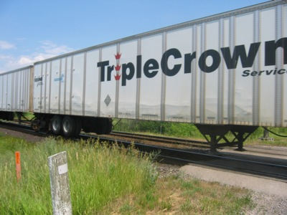

Welded Rail Carrier Flatcars were created to move long segments of rail to where they would be needed for building new sections of track. These flatcars have special frames with rollers, and the long rail segments span the length of many cars. Special cars at one end guide the rail to the ground beside the existing track, and they cut the end to the needed length for welding. Note the walkway above the rail rollers.  Photo by David Graham. | 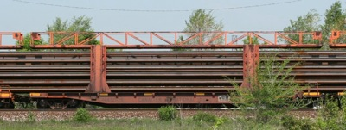

Heavyweight Flatcars were developed to move very heavy loads. The loads may not have been big, but they were always heavy. The extra wheels on each end of the car helped to distribute the weight.  In this picture, the car is also a Depressed-Center Flatcar, where the load has been lowered closer to the ground, to allow for larger freight to be carried over the rails.  Photo by David Graham. | 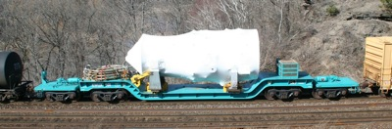

A Schnabel Railroad Car is different, because the freight is a center component, bolted to the articulated supports mounted above many sets of wheels. All of the extra axles help distribute all that weight, but the axles are set up in pairs, so they are still able to turn along the tracks. By putting all the wheels on each end (beyond the freight component), you also allow the center of gravity for the freight to be closer to the ground.  Photo by David Graham.  ( S. Berliner's SCHNABEL pages )  ( ETMX1001 page ) | 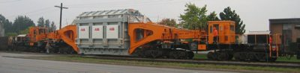

Bulkhead Flatcars were created to help keep loads from shifting forward during sudden stops.  If the loads were to slide forward during a sudden stop, they could damage the rail cars ahead of them, or damage freight (the the next car was a flatcar, and that load had not shifted).  Photo by David Graham. | 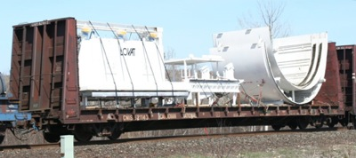

Center-Beam Flatcars were created to help keep loads from shifting from side to side (especially along windy tracks through the mountains), and they are often used for shipping large batches of cut lumber to market.  Because there is a beam along the center of the car, these cars need to be loaded, and unloaded, from both sides at once, to prevent them from tipping over.  Photo by Chris vanderHeide. | 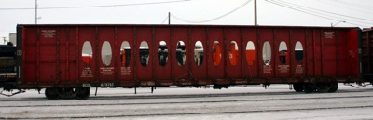

Airplance Fuselage Segment Transporter, built for the Boeing Corporation, for moving parts of planes that are built in one factory to another factry where they can be assembled into full airplanes (and then they can be flown to their new owners.)  This is a specialty flatcar, with the sliding covers to protect the freight while in transit. These covers slide out to the ends of the car for loading and unloading of these large freight loads.  Photo by Ryan Wilkerson. | 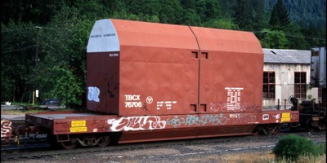

Automotive Carriers
Two and three-deck automobile carriers were another special adaptation of the flatcar. While they allowed you to carry two or three times as many vehicles as a normal flatcar, they did require special loading and unloading facilities, which led to their use in automotive Unit Trains.
The open frame version left the valuable freight exposed to rain, dirt, and flying debris (including rocks thrown at the train). If a window was broken enroute, rain or animals could get inside the vehicle and cause costly damage. It was these costs that drove the railroads and the auto industry to devcelop the enclosed Auto Rack train cars.
Notice that the Auto Rack car is not completely enclosed. The small vents keep fumes from gathering in the car, allow crews to see if the car is empty or loaded without opening the doors, and slightly reduces the wind load that these tall cars present when the winds are coming directly into the side of the train.
Open-frame Auto Carriers were a double- or triple-decker version of the drive on/drive off flatcar, meant to carry automobiles from the factory to near-market. However, these left the vehicles exposed to the weather, flying debris, and theft of contents during the trip. Later versions had heavy screens welded along the sides to try to prevent some of the problems.  Photo by Jim Sands. | 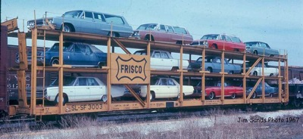

Auto Transporters (or "auto racks") are the modern method for moving automobiles by rail. They have two or three decks inside, and (like their flatcar ancestors) they have ramps on the ends of each deck. When these cars are lined up at a loading facility, the end doors are opened, the ramps on the decks are connected to the next auto rack, and then cars can be driven through these 'tunnels' for loading and unloading.  Photo by Chris vanderHeide. | 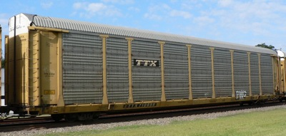

Intermodal Container Cars
Intermodal Cars are meant to cary the standard-sized intermodal freight containers. (These containers can move from ships, to trailers, to trains using cranes at intermodal freight terminals, without needing to unload and reload the freight.)  While you could use a plain flatcar, specialized Intermodal Flatcars provide secure mounting and faster loadig and unloading of the containers.  Photo by David Graham. | 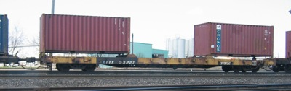

Intermodal 'Well' Cars (also called by the trademarked name "Stack Trains") are like drop-bottom flatcars for intermodal freight containers. The lower bed allows for "double-stacks" (two containers tall) to fit through tunnels and bridge portals.  Another aspect is that a 'single well car' can have three, four, or 5 beds between the couplers, using shared wheel-sets between the beds, to reduce the friction of some unneeded axles.  Photo by David Graham. | 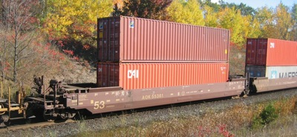

Intermodal "Spine Cars" are another flatcar variant. They have a very narow bed, and they have outrigger arms that stick out to the normal width to support the ends of the intermodal containers. This makes them lighter than a normal flatcar.  In the picture to the right, you can also see the shared wheelset (truck) in between the two car body segments. By sharing one pair of axles, the cars also elimenate the rolling resistance of another pair of axles, as well as the weight of that extra wheelset. | 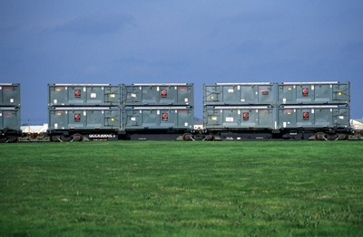

Log Cars are a variant of the Spine Cars, but sometimes a Flatcar would be used as a base as well. The tall steel posts would hold large sections of tree trunks (lined up the same direction of the train, and not longer than the ends of the car). This made them easier to unload using special cranes with 'claws' at their destination.  Photo by Ryan Wilkerson. | 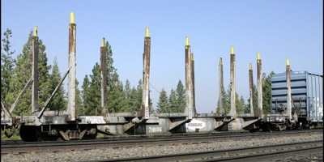

Gondolas
Gondolas are basically a flatcar with short or tall walls. Those walls keep the freight from shifting during transit, but don't keep it safe, or protect it from the weather. The are used to carry loads that can be loaded by dropping into the car, and can be unloaded by picking it up from above the car.  Photo by Chris vanderHeide. | 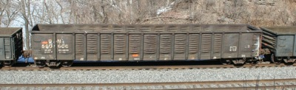

Side-Dump Gondolas are a special variation of gondola which can dump its load to either side of the tracks, but not between the tracks (so this is NOT a Hopper car).  The clues to look for are the smaller shutes under the car (between the rails) AND the hinges along the side walls. The walls help to ensure that the contents of the gondola falls away from the ballast roadbed.  This car can dump to either side of the train, as may be needed. Cars like this might be used to dump eavy rocks beside the Right-of-Way, to help protect the ballast from approacing flood waters. | 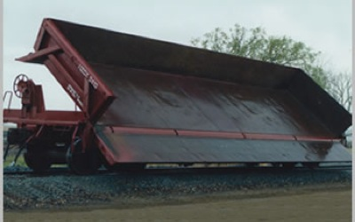

Coiled Steel cars are a variation of the flatcar or the gondola. These cars have a cover that can be attached after the freight is loaded, which provides some protection in transit. At the destination, the covers are lifted off, and the freight is removed using cranes. | 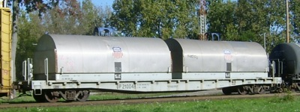

Boxcars
Boxcars were designed to cover freight that needed to be covered or secured while in transit. This kept the sun off the freight, kept it dry from the rain, and protected it from rocks and debris wile on its trip.  The boxcar in the picture to the right is also taller than the standard boxcar. You can spot these "excess-height" cards by the white stripe at the top of both ends of the car. The height of the car is stenciled on both ends, so crews can try to prevent these taller cars from going into older, shorter tunnels, bridge portals, and service buildings.  Photo by Ryan Wilkerson. | 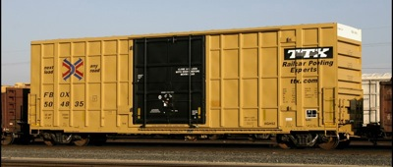

Stock Cars were boxcars made to move livestock, most often cattle. They often had wooden sides, with gaps between the wooden slats. This allowed good air circulation for the animals, while keeping them corraled during their trips. Some cars had multiple levels, for carrying smaller animals.  Photo by Jim Sands. | 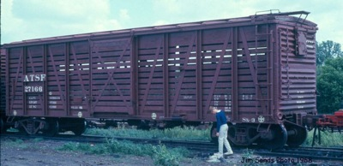

Refrigerated 'Icebox' Boxcars were designed to get fresh produce to market across longer distances. These modified boxcars had insulated floors, roof, and walls, to keep the sun and outside temperatures from affecting the freight. These icebox reefers had hatches in the roof at each end of the car for loading ice into trays at the top of the car, which keept the produce cool, and the ice was refilled at stations along the trip. The roof hatches were the clue that the car was a reefer.  Photo by Jim Sands. | 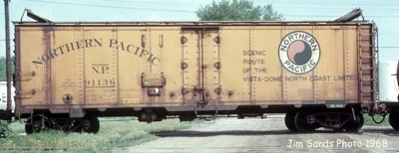

Modern Refrigerated Boxcars have special doors, and thicker walls. Instead of ice, they use a refrigerator, similar to the one in your kitchen, with a generator and a fuel tank on each of these cars. You can spot them by looking for the cooling vents near the ends of the cars, looking for the fuel tank under the car, or listening for the motor as the train cars pass by.  Photo by David Graham. | 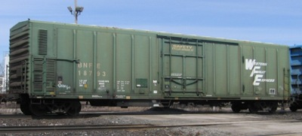

This is another Modern Refrigerated Boxcar, where the chiller unit is mounted to the outside of the car (on the end to the right in this picture.) These used an air conditioner very much like the types used on refrigerated trailers used on the roads.  Photo by David Graham. | 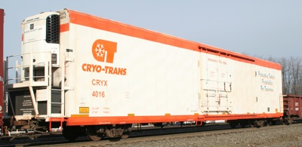

Tank Cars are used to move liquids by rail. There are many types, but you need to look closely to see the differences. Most tank cars have a layer of insulation inside the shell that you see, and an inner tank for the freight. Some liquids need to be kept HOT in transit (plastics, tars), while others need to be kept very cold (or they will become gases). Some tank cars actally carry pressurized gases, such as propane.  Most tank cars these days carry only one comodity, but older cars had two or three sections inside. (Look for the number of 'domes' on top used for loading, for a clue to the number of compartments inside.)  Photo by David K. Z. Harris. | 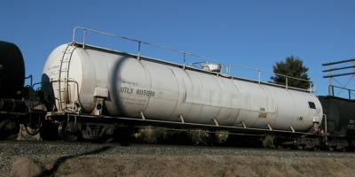

Hoppers
Hoppers have open tops - open to the sun, air, rain and snow. The freieght will get dusty during the trip, and some of it could even blow away or fall out along the track.  Hoppers look like Gondolas with tall walls, but the clue to look for is the triangular discharge bays under the car.  These cars are meant to have freight (coal, rock, etc.) dropped into the top, but are unloaded through the chutes at the bottom of the car. These cars have steep, angular sides on the inside of the car, to help the freight move out when the discharge ports are opened. The ports underneath are meant to drop the freight between the ties, to waiting conveyor systems underneath.  Photo by Chris vanderHeide. | 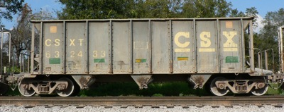

Ballast Hoppers were designed to dump their load to the outside of the rails, as well as dumping the load between the rails.  The car in the picture to the right has long doors alined above the rails, which can dump its load either between the rails, or outside the rails on the ties for Maintanance of Way work.  Photo by David Graham. | 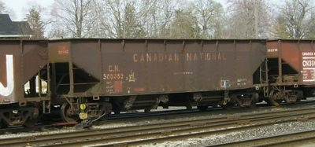

Covered Hoppers are still hoppers, but with a cover on them. They are used for freight that is smaller and lighter (corn and grain, plastic particles for factories), that might blow away when the train is in transit, or for freight that shouldn't get wet or dirty during the trip (powdered products, including cement and flour). These empty through discharge ports in the bottom, but may have smaller ports and valves.  Photo by Ryan Wilkerson. | 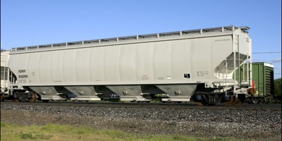

Cabooses
We don't often see cabooses in normal freight operation anymore, although you may be able to see them in operation on Museum Railroads. Not only did they play an important role in the early life of the railroads, but they also have something to do with some of the safety requirements you may study as part of earning your Railroading Merit Badge.
Cabooses were initially made from old boxcars, but later became a specific type of car. They were the conductor's office at the rear of the train, as well as the sleeping quarters for the brakemen. The crew had equipment to monitor the air pressure in the train brake line, as well as to be able to control the brakes in an emergency. They usually had a small covered porch/platform at each end. At the rear of the train, the crew could watch for smoke (or smell it), and watch for trouble at the rear of longer trains.
To make it easier to see along the length of the train, the Bay Window Caboose had small extensions from the body of the caboose, allowing the crew an easy way to look down the sides without leaning out of the car.  A Caboose usually has a brake wheel on each end, as well as ladders to climb up to the roof.  Photo by Chris vanderHeide. | 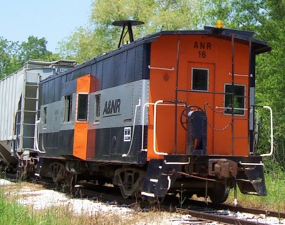

The Cupola Caboose has a small observation deck sticking up from the top of the caboose. From this high vantage point, the crew could look forward along the top of the train. This was probably the most common type of caboose.  The caboose was the Conductor's rolling office, and the Brakeman's Hotel. Some bench seats could become a bed, many had a hot stove for heating as well as cooking.  Note all of the 'grab-irons' (safety railings) on the cabooses pictured here.  Photo by David Graham. | 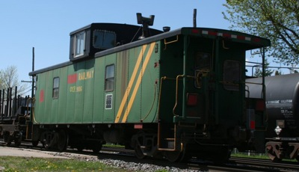

Passenger Service Cars
Baggage Cars typically have a couple large doors, and only a few small windows, and are usually found between the locomotives and the coaches on passenger trains.  There are doors on the end of the baggage cars, so that the crews can pass through them during the voyage, but the passengers rarely get to go inside these cars.  Photo by Ryan Wilkerson. | 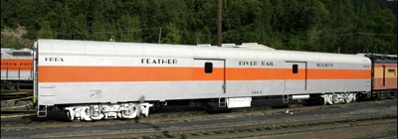

Combination (Combine) Cars were usually found on railroads with smaller traveling populations. For the weight of a single coach, the railroad would have the capacity of two smaller cars.  The picture to the right shows a Baggage and Rolling Post Office Combine car. In front of the small door, you can see the mailbag catcher, and a few windows to let light in for the postal clerks.  The most common Combine was a passenger and baggage combination. You would find many windows on one end, and a large freight door on the other end.  Photo by David K. Z. Harris | 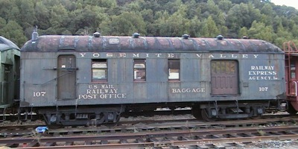

Passenger Coaches usually have large windows down the side of the coach, so that the passengers can enjoy the view of the passing scenery. Smaller windows may indicate a bathroom, or small crew quarters on either end of the coach.  The Royal Gorge was the name given to the 782 mile Rio Grande route between Denver, Colorado and Ogden, Utah.  Photo by Ryan Wilkerson. | 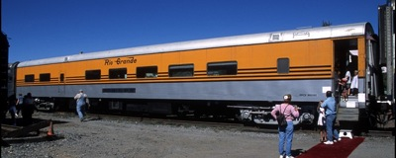

Sleeping Cars used to have small windows in each sleeping room, and some had a shared bathroom between two sleeping rooms. You would sleep in your room, and the porter would stow or convert your bed into a bench seat during the day. | 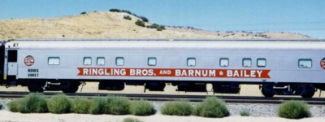

Dome Cars were some of the first cars to give some passengers this elevated view of the landscape around the trains. The seats faces forward, and passengers could see to the front, as well as both sides (and even to the rear, if they wanted to kneel on their chair).  Because there were so few seats with this special view on each train, it was considered good ettiquete to only sit for an hour or so, and then you would go back downstairs to allow someone else the chance to enjoy the view.  I believe the car in this picture is ex-Atchison, Topeka & Santa Fe #503. The Niles Canyon Railway is currently hosting ATSF #505 during restoration. Only 6 of this car were made, and all of them survive to this day under private ownership.  Photo by Ryan Wilkerson. | 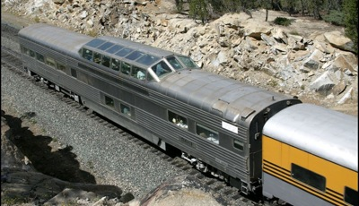

Double-decker Passenger Coaches are quite common on todays commuter trains, and on Amtrak's long-distance trains. Many passengers can enjoy the view from the higher seats for most of their trip, while others who would rather be reading (or napping) could sit downstairs, waiting to arrive at their destinations.  This distinctive style coach can be found in many places, including the GO Trains in Toronto, Canada; The Sounder trains near Seattle, WA; The Altamont Commuter Express (ACE) trains, and the CalTrain high-speed trains in the San Francisco Bay Area.  Photo by David Graham. | 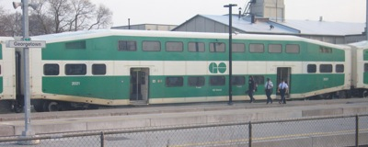

Double-deck Observation Cars are the newer versions of the Domed Observation Car, with seats along the second deck that face out to the sides. These allow more people to enjoy the view from these high seats, and are more common on todays long Amtrak trains.  The Pacific Parlour car is only found on the Coast Starlight trains.  Photo by Steven Reynolds. | 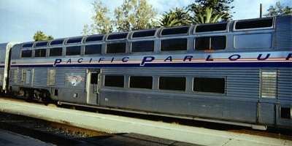

Parlour Cars were typically at the rear end of the passenger trains. They would often have white lights facing the track, so the conductor could see for reverse moves (that is, for backing up) at night, just like most cabooses had white lights, as well as red lights.  Parlour cars often had private rooms on one end, and they had a large lounge and a small porch under the cover of the roof at the other end, as in the picture to the right.  Photo by Ryan Wilkerson. | 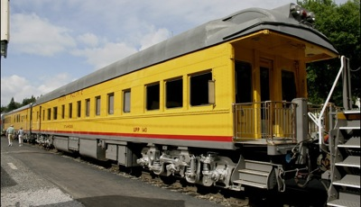

Cab Cars are a special variant of the Double-deck Passenger Coach. They are used on commuter trains, at the end of the train opposite from the locomotive. Notice that I didn't say at the back of the train.  In what is called push-pull service, the locomotive pulls the train the way you would expect in one direction. Later, the engineer actually will sit in the Cab Car, and control the locomotive from a control stand in the Cab Car at the 'front' of the train, while the locomotive pushes the train back the other direction.  The clues to look for on a Cab Car are the white lights facing the tracks, the horns, and the windows with windshield wipers facing the tracks. You may also see the MU (multiple-unit) hoses, and the F Front designation found on a locomotive.  Photo by David K. Z. Harris | 